Games questionnaire
- Do you have a games console at home or do you play games on your Computer? If so what do you have? (Xbox, Nintendo, Playstation, PSP)

- What games do you mostly enjoy playing? (Action/Adventure/Racing/Fighting)

- What do you think makes a good game?

- Should there always be a scoring system on games? Why?

- Match up the games console with its manufacturer.
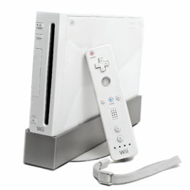(Wii) | 
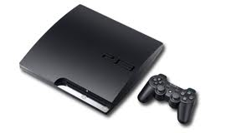  (Playstation) | 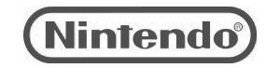
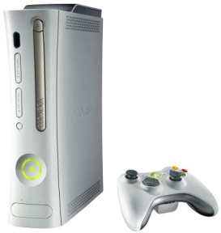 (Xbox) | 
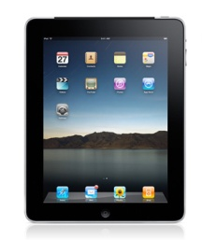 (iPad) | 